Name: ___________________________________________ Date: ________________ Period: __________
Rate Tables and Graphing
Rate Table: A table that shows the value of a single item in terms of another item. It is used to show equivalent ratios of the two items.

1.) Complete the rate table comparing feet to yards.
Feet 3 6 24 42
Yards 1 3 8
a.) How many feet are in 3 yards?

b.) How many yards would be equivalent 42 feet? (Set up a proportion)

c.) Write a comparison statement using “for every” or “per” to describe the relationship between feet and yards. ___________________________________________________________________________________________ ___________________________________________________________________________________________

- The cost of one movie ticket is $6.50. (This is the unit rate because it tells us the price “per” one ticket)
- Complete the following data table to show the relationship between the number of tickets purchased and the total cost.
Price ($) 6.50 13 26 45.50
Tickets 1 2 3 4 5 6 7 8

- What is the total price when purchasing 12 tickets at a cost (unit rate) of $6.50 per ticket?
**Set up a proportion to prove your answer!

Graphing from Rate Tables
Ratios can be written as ordered pairs (x, y) and plotted on a coordinate plane to show the proportional relationship between the quantities.
Example 1:
At a used bookstore, customers can buy 3 books for $2. Use equivalent ratios to graph the number of books and their cost. Graph the number of books on the x-axis and the cost on the y-axis.
Step One: Write a ratio that describes the information given in the problem.
__________________________________________________________________________________________
Step Two: Make a table of equivalent ratios, also called a rate table.
Step Three: Write the ratios as ordered pairs.
Books (x) | Price in dollars (y)
3 | 2
 | 4
9
 | 10

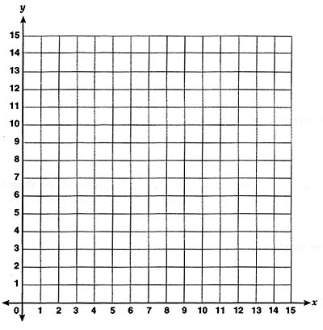
Step Four: Plot the ordered pairs on a coordinate plane. Connect the points to make a line.

Price in dollars

Number of books

Example 2: On a bicycle, Bill can travel 20 miles in 4 hours, at a constant speed.
a.) Create your own rate table to show the relationship between these two quantities. You can start with the given ratio, and then work backwards to 1 hour to find the rate per hour.
Time in hours (x) | .5 | 1 |  |  | 4
Distance in miles (y) |  |  |  |  | 20

Ordered Pairs:

- What is the unit rate of the distance he can travel in 1 hour?

- Use the rate table above to write the ratios as ordered pairs. Then, graph the time on the x-axis and the distance on the y-axis to show the relationship between the two quantities.
Bill’s Biking Distances

Distance in miles
0 3 6 9 12 15 18 21 24 27 30 33

0 1 2 3 4 5 6
Time in hours

- How can you use the graph to prove the number of miles Bill can travel in 5 hours?

________________________________________________________________________________________________________________________________________________________________________________________________________________________________________________________________________

Problem Solving with Rates
1.) A typical container of frozen orange juice concentrate holds 12 fluid ounces. The standard recipe is “Mix one can of concentrate with three cans of cold water.”
a.) What is the ratio of concentrate to water?

b.) How large of a container will you need to hold the juice once mixing the 12 oz concentrate with the equivalent ratio of water? Once you find the equivalent ratio, you will need to add the two liquids.

2.) On Friday, three friends shared how much they read during the week. Barbara read the first 100 pages from a 320 page book in the last 4 days. Colleen read the first 54 pages from a 260 page book in the last 3 days. Nancy read the first 160 pages from a 480 page book in the last 5 days.
a. )A person’s average reading rate can be defined by the number of pages read by the number of reading days.
What is each girl’s reading rate (pages per day)?

Barbara: ____________________________

Colleen: ____________________________

Nancy: ______________________________

b.) If three friends continue to read every day at their rate, which girl will finish reading their book first?

3.) Write your own unit rate word problem. You may use ads to compare two quantities to find a better unit price, or you can come up with your own comparison of two quantities. Make sure to solve your problem so you know that it works out!

__________________________________________________________________________________________________
__________________________________________________________________________________________________
__________________________________________________________________________________________________

